Books around Diversity
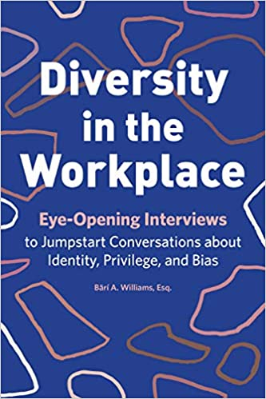 | This book gathers first-hand accounts of minority experiences in the workplace. The book explores a wide range of distinguishers, including race, gender, age, ability, religion, and LGBTQ. While many diversity books focus on singular identities, this book gives a nod to intersectionality and the differences of experience involved in belonging to multiple minority groups. The book provides space for reflection at the end of each section, as well as tips for carrying out constructive conversations about inclusion with colleagues.
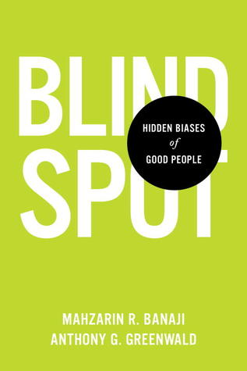 | These self-perceptions are challenged by leading psychologists Mahzarin R. Banaji and Anthony G. Greenwald as they explore the hidden biases we all carry from a lifetime of exposure to cultural attitudes about age, gender, race, ethnicity, religion, social class, sexuality, disability status, and nationality.  “Blindspot” is the authors’ metaphor for the portion of the mind that houses hidden biases. Writing with simplicity and verve, Banaji and Greenwald question the extent to which our perceptions of social groups—without our awareness or conscious control—shape our likes and dislikes and our judgments about people’s character, abilities, and potential.  In Blindspot, the authors reveal hidden biases based on their experience with the Implicit Association Test, a method that has revolutionized the way scientists learn about the human mind and that gives us a glimpse into what lies within the metaphoric blindspot.  The title’s “good people” are those of us who strive to align our behavior with our intentions. The aim of Blindspot is to explain the science in plain enough language to help well-intentioned people achieve that alignment. By gaining awareness, we can adapt beliefs and behavior and “outsmart the machine” in our heads so we can be fairer to those around us. Venturing into this book is an invitation to understand our own minds.
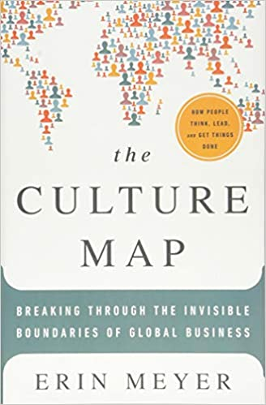 | As the business world becomes more globalized, having international colleagues becomes the norm. Society greatly influences individual’s attitudes and approaches to work, and differences in cultures can lead to misunderstandings. This book is a guide to navigating internationally diverse workplaces. The book explores differences in factors like communication style, demeanor, and attitudes about authority across cultures. The Culture Map offers advice in areas such as performance reviews, sales pitches, and scheduling. This book is a great resource not only for accommodating diverse staff, but also for forging relationships with international clients and vendors.
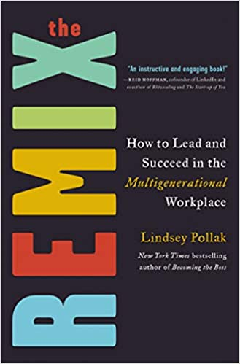 | Diversity does not only apply to factors like race and gender, but also to age. The workforce currently consists of four generations with differing work-styles and ideals. Managing across life stages and experience levels can be a challenge. The Remix is a guide to leading multiple generations without alienating particular age demographics. The book offers advice about bridging gaps in communication, culture, and values and soliciting the best performance from every age group.
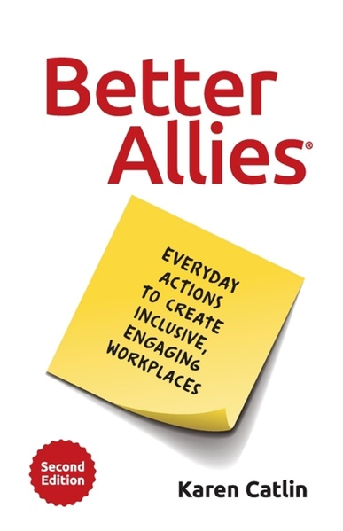 | Since originally publishing Better Allies in 2019, Karen Catlin has amassed dozens of new scenarios and insights through her talks, workshops, and community interactions. In this fully revised second edition, you'll learn to spot situations where you can create a more inclusive culture, along with straightforward steps to take and changes to make. Catlin, a highly-sought after expert on allyship, will walk you through:  * Attracting and hiring a diverse workforce  * Cultivating an environment where co-workers feel welcome, respected, and supported  * Amplifying and advocating for others  * Giving effective and equitable performance feedback  * Using more inclusive language  * Running inclusive conferences and events
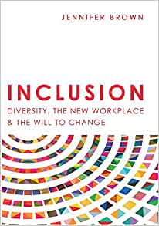 | The book acknowledges that change is hard, but necessary. The global landscape is ever-shifting, and inclusive workplaces are the way of the future. The momentum towards more diverse companies will not slow or reverse, and tomorrow’s most successful organizations embrace this fact. Change is never easy though.  This book envisions a future where all employees feel welcomed, appreciated, and acknowledged, but only after the workforce overcomes current discomforts and roadblocks. This book presents strategies to help workers and executives appreciate the need for increased diversity and inclusion, both for the sake of underrepresented employees and the business’s bottom line.
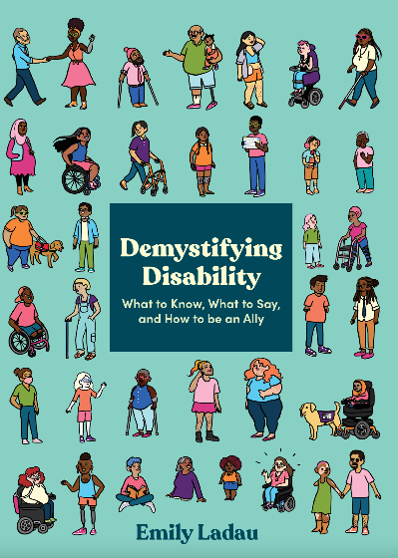 | An approachable guide to being a thoughtful, informed ally to disabled people, with actionable steps for what to say and do (and what not to do) and how you can help make the world a more accessible, inclusive place.  Disabled people are the world’s largest minority, an estimated 15 percent of the global population. But many of us–disabled and non-disabled alike–don’t know how to act, what to say, or how to be an ally to the disability community. Demystifying Disability is a friendly handbook on important disability issues you need to know about, including:  • How to appreciate disability history and identity  • How to recognize and avoid ableism (discrimination toward disabled people)  • How to be mindful of good disability etiquette  • How to appropriately think, talk, and ask about disability  • How to ensure accessibility becomes your standard practice, from everyday communication to planning special events  • How to identify and speak up about disability stereotypes in media  Authored by celebrated disability rights advocate, speaker, and writer Emily Ladau, this practical, intersectional guide offers all readers a welcoming place to understand disability as part of the human experience
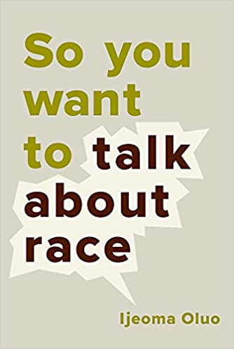 | This book is one of the best-selling books about diversity. Ijeoma Oluo drudges up all the most controversial talking points about race, offering clear and constructive ways to approach every conversation. The book covers concepts like police brutality, cultural appropriation, affirmative action, intersectionality, and privilege. The tone is equal parts entertaining, enlightening, and mobilizing. So You Want to Talk About Race is a great fit for professionals who want to know how to talk about race and what to do to promote racial justice inside of work and out.  Notable Quote: “You have to get over the fear of facing the worst in yourself. You should instead fear unexamined racism. Fear the thought that right now, you could be contributing to the oppression of others and you don’t know it. But do not fear those who bring that oppression to light. Do not fear the opportunity to do better.”
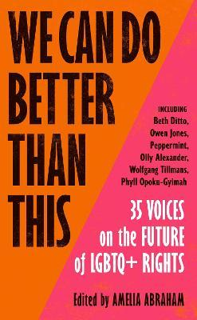 | In We Can Do Better Than This, 35 voices - actors, musicians, writers, artists and activists - answer this vital question, at a time when the queer community continues to suffer discrimination and extreme violence. Through deeply moving stories and provocative new arguments on safety and visibility, dating and gender, care and community, they present a powerful manifesto for how - together - we can change lives everywhere.
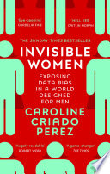 | From government policy and medical research, to technology, workplaces, and the media. Invisible Women reveals how in a world built for and by men we are systematically ignoring half of the population, often with disastrous consequences. Caroline Criado Perez brings together for the first time an impressive range of case studies, stories and new research from across the world that illustrate the hidden ways in which women are forgotten, and the profound impact this has on us all.
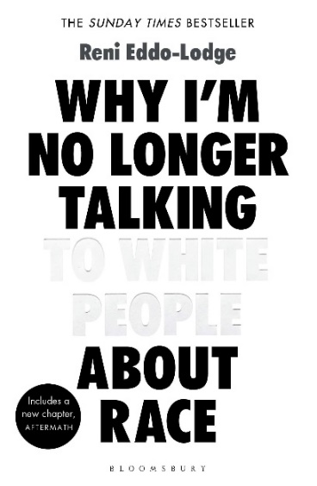 | The book that sparked a national conversation. Exploring everything from eradicated black history to the inextricable link between class and race, Why I'm No Longer Talking to White People About Race is the essential handbook for anyone who wants to understand race relations in Britain today.
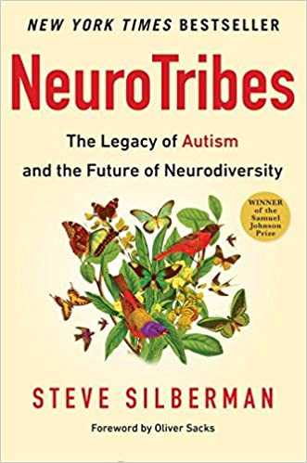 | Going back to the earliest days of autism research and chronicling the brave and lonely journey of autistic people and their families through the decades, Silberman provides long-sought solutions to the autism puzzle, while mapping out a path for our society toward a more humane world in which people with learning differences and those who love them have access to the resources they need to live happier, healthier, more secure, and more meaningful lives.  Along the way, he reveals the untold story of Hans Asperger, the father of Asperger’s syndrome, whose “little professors” were targeted by the darkest social-engineering experiment in human history; exposes the covert campaign by child psychiatrist Leo Kanner to suppress knowledge of the autism spectrum for fifty years; and casts light on the growing movement of "neurodiversity" activists seeking respect, support, technological innovation, accommodations in the workplace and in education, and the right to self-determination for those with cognitive differences.
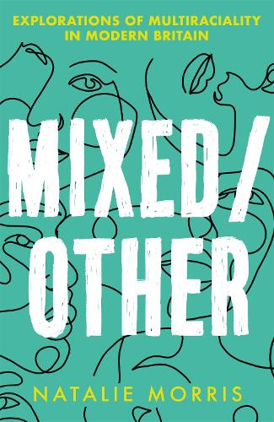 | Instagram feeds and our high street shop windows, and when children of interracial relationships are lauded as heralding in the dawn of a post-racial utopia, journalist Natalie Morris takes a deep dive into what it really means to be mixed in Britain today.  From blackfishing to the fetishisation of mixed babies; from the complexities of passing and code-switching to navigating the world of work and dating, Natalie explores the ways in which all of these issues uniquely impact those of mixed heritage. Drawing from a wealth of research, interviews and her own personal experiences, in Mixed/Other, Natalie's aims to dismantle the stereotypes that have plagued mixed people for generations and to amplify the voices of mixed Britons today, shining a light on the struggles and the joys that come with being mixed.
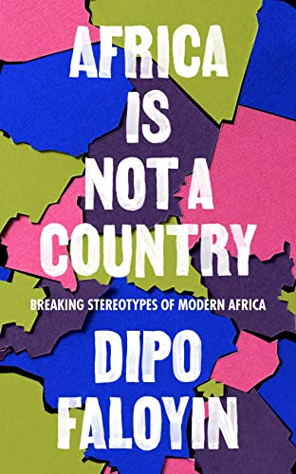 | Africa Is Not a Country is a kaleidoscopic portrait of modern Africa that pushes back against harmful stereotypes to tell a more comprehensive story.  You already know these stereotypes. So often Africa is depicted simplistically as an arid red landscape of famines and safaris, uniquely plagued by poverty and strife. In this funny and insightful book, Dipo Faloyin offers a much-needed corrective, creating a fresh and multifaceted view of this vast continent.  To unspool this inaccurate narrative, Africa Is Not a Country looks to a wide range of subjects, from chronicling urban life in Lagos and the lively West African rivalry over who makes the best Jollof rice, to the story of democracy in seven dictatorships and the dangers of white saviourism and harmful stereotypes in popular culture.  It examines how each African country was formed, by white European explorers who turned up with loose maps and even looser morals, how 90 per cent of Africa's material cultural legacy was stolen during the colonial era, and the fight to get those artefacts back.  By turns intimate and political, Africa Is Not a Country brings the story of the continent towards reality, celebrating the energy and fabric of its different cultures and communities in a way that has never been done before.
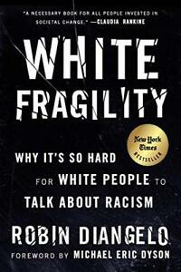 | Anger. Fear. Guilt. Denial. Silence. These are the ways in which ordinary white people react when it is pointed out to them that they have done or said something that has - unintentionally - caused racial offence or hurt. After, all, a racist is the worst thing a person can be, right? But these reactions only serve to silence people of colour, who cannot give honest feedback to 'liberal' white people lest they provoke a dangerous emotional reaction.  Robin DiAngelo coined the term 'White Fragility' in 2011 to describe this process and is here to show us how it serves to uphold the system of white supremacy. Using knowledge and insight gained over decades of running racial awareness workshops and working on this idea as a Professor of Whiteness Studies, she shows us how we can start having more honest conversations, listen to each other better and react to feedback with grace and humility. It is not enough to simply hold abstract progressive views and condemn the obvious racists on social media - change starts with us all at a practical, granular level, and it is time for all white people to take responsibility for relinquishing their own racial supremacy.
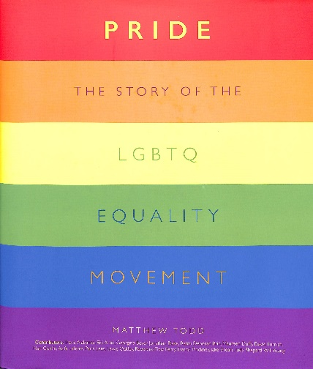 | In June 1969, police raided New York gay bar the Stonewall Inn. Pride charts the events of that night, the days and nights of rioting that followed, the ensuing organization of local members of the community – and the 50 years since in which activists and ordinary people have dedicated their lives to reversing the global position.  Pride documents the milestones in the fight for LGBTQ equality, from the victories of early activists to the passing of legislation barring discrimination, and the gradual acceptance of the LGBTQ community in politics, sport, culture and the media. Rare images and documents cover the seminal moments, events and breakthroughs of the movement, while personal testimonies share the voices of key figures on a broad range of topics. Pride is a unique celebration of LGBTQ culture, an account of the ongoing challenges facing the community, and a testament to the equal rights that have been won for many as a result of the passion and determination of this mass movement.
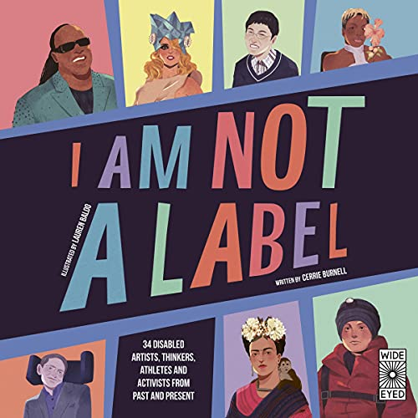 | In this biography anthology, meet 34 artists, thinkers, athletes and activists with disabilities, from past and present. From Frida Kahlo to Stephen Hawking, find out how these iconic figures have overcome obstacles, owned their differences and paved the way for others by making their bodies and minds work for them.  These short biographies tell the stories of people who have faced unique challenges which have not stopped them from becoming trailblazers, innovators, advocates, and makers. Each person is a leading figure in their field, be it sport, science, math, art, breakdance, or the world of pop.  Challenge your preconceptions of disability and mental health with the eye-opening stories of these remarkable people:  Ludwig van Beethoven, Gustav Kirchoff, Henri Matisse, Eliza Suggs, Helen Keller, Frida Kahlo, John Nash, Stephen Hawking, Temple Grandin, Stevie Wonder, Nabil Shaban, Terry Fox, Peter Dinklage, Wanda Diaz Merced, Emmanuel Ofosu Yeboah, Dr Victor Pineda, Farida Bedwei, Stella Young, Lady Gaga, Arunima Sinha, Naoki Higashida, Isabella Spingmuhl Tejada, Aaron Philip, Catalina Devandas Aguilar, Redouan Ait Chitt, Jonas Jacobsson, Trischa Zorn, Ade Adepitan, and Dynamo.  This book is there to help us all, to encourage us to talk about how we’re all different.
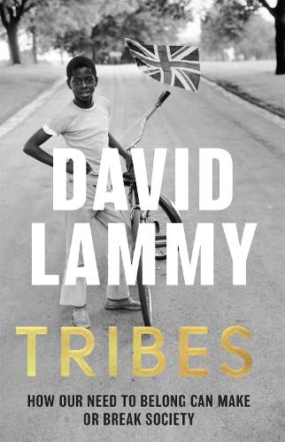 | Both memoir and call-to-arms, Tribes explores both the benign and malign effects of our need to belong. How this need - genetically programmed and socially acquired - can manifest itself in positive ways, collaboratively achieving great things that individuals alone cannot. And yet how, in recent years, globalisation and digitisation have led to new, more pernicious kinds of tribalism. This book is a fascinating and perceptive analysis of not only the way the world works but also the way we really are.
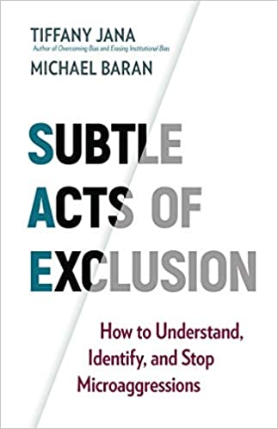 | This book examines microaggressions, or subtle phrases or actions that cause marginalized individuals discomfort or distress. This book is important because many folks think of racism as intentional, but innocuous behaviours can be just as harmful. Subtle Acts of Exclusion demonstrates how to avoid alienating group members and presents a formula for building trust and rapport between team members of all backgrounds
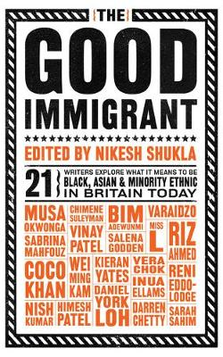 | How does it feel to be constantly regarded as a potential threat, strip-searched at every airport? Or be told that, as an actress, the part you’re most fitted to play is ‘wife of a terrorist’? How does it feel to have words from your native language misused, misappropriated and used aggressively towards you? How does it feel to hear a child of colour say in a classroom that stories can only be about white people? How does it feel to go ‘home’ to India when your home is really London? What is it like to feel you always have to be an ambassador for your race? How does it feel to always tick ‘Other’?  Bringing together 21 exciting black, Asian and minority ethnic voices emerging in Britain today, The Good Immigrant explores why immigrants come to the UK, why they stay and what it means to be ‘other’ in a country that doesn’t seem to want you, doesn’t truly accept you – however many generations you’ve been here – but still needs you for its diversity monitoring forms.  Inspired by discussion around why society appears to deem people of colour as bad immigrants – job stealers, benefit scroungers, undeserving refugees – until, by winning Olympic races or baking good cakes, or being conscientious doctors, they cross over and become good immigrants, editor Nikesh Shukla has compiled a collection of essays that are poignant, challenging, angry, humorous, heartbreaking, polemic, weary and – most importantly – real.
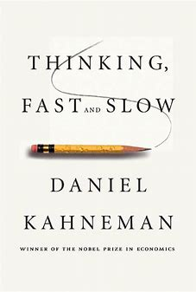 | Why is there more chance we'll believe something if it's in a bold type face? Why are judges more likely to deny parole before lunch? Why do we assume a good-looking person will be more competent? The answer lies in the two ways we make choices: fast, intuitive thinking, and slow, rational thinking. This book reveals how our minds are tripped up by error and prejudice (even when we think we are being logical), and gives you practical techniques for slower, smarter thinking. It will enable to you make better decisions at work, at home, and in everything you do.
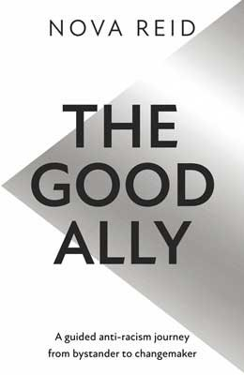 | The Good Ally is an urgent call to arms to become better allies against racism and provides a thoughtful approach, centering collective healing, to do so.  It is a book for those against persistent racial injustice, hungry to expand their knowledge and understanding of systemic racism in Britain and beyond. It uncovers the roots of racism and its birthplace, anti-Blackness.  It is for those who not only want to be able to better recognise both subtle and overt forms of racism in action, to examine their powerful role in it, but who want to know what to do about it. The answer often lies within.  The Good Ally is the answer to ‘what next?’

Films around Disability
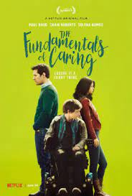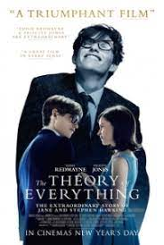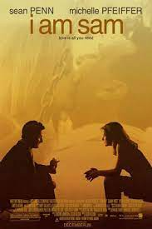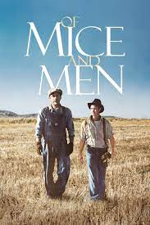
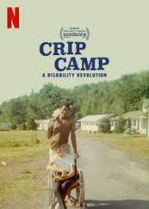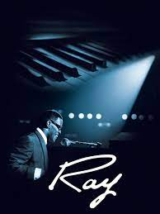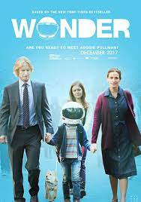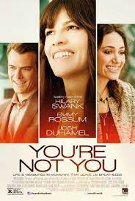
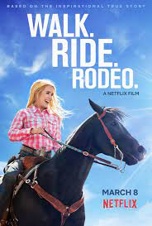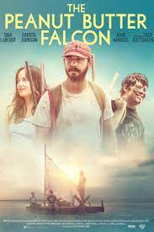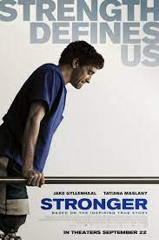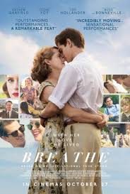
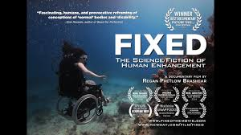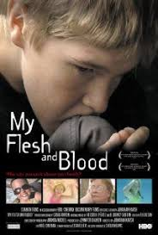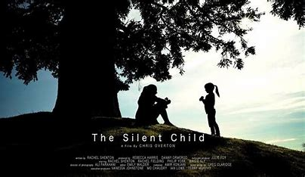
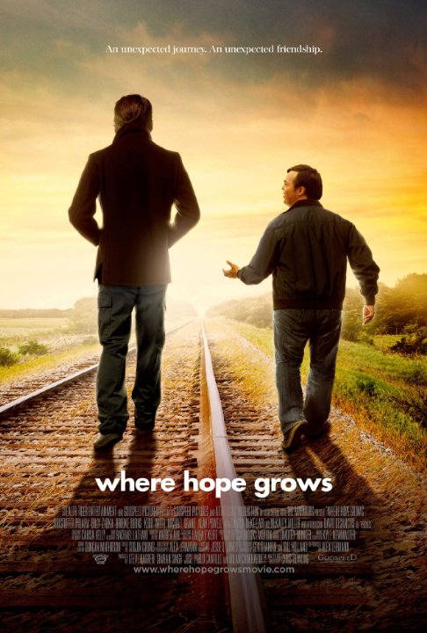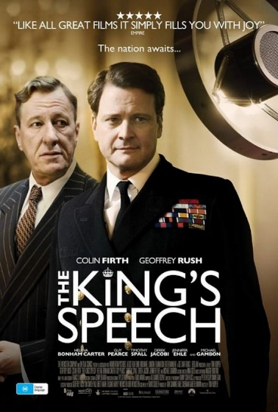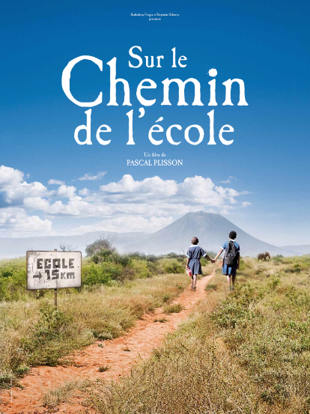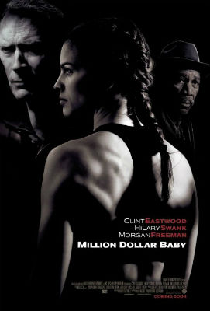

 | South Asian Heritage Books
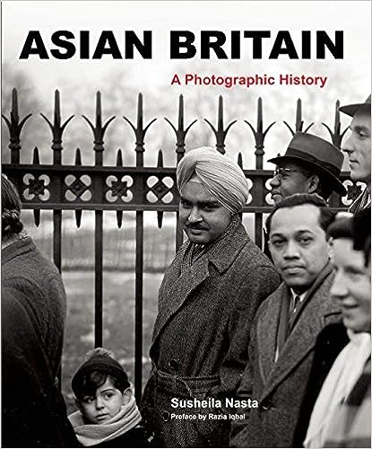 | Asian Britain  South Asians have lived in Britain for centuries. From the first trade conducted between the two nations along the Silk Route to the adoption of Chicken Tikka Masala as a national dish, the ongoing mutual exchange of cultures continues to flourish today. Asian Britain vividly charts Britain s process of coming to terms with the historic realities of its culturally diverse past and present.  This extraordinary photographic history draws upon culture, film, music, the military, business, the suffragist movement and the different phases of historic settlement of Asian migrants from the subcontinent, the Caribbean and East Africa. Personalities from the arts, business, politics and sport appear alongside the pioneers the first female law student at Oxford, the first Indian RAF pilots, the first Asian MP and of equal significance are the experiences and history of the ordinary immigrants.
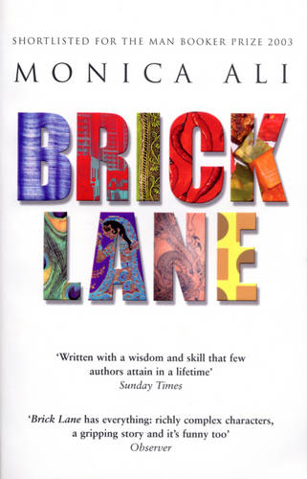 | Brick Lane  Still in her teenage years, Nazneen finds herself in an arranged marriage with a disappointed older man. Away from her Bangladeshi village, home is now a cramped flat in a high-rise block in London's East End. Nazneen knows not a word of English, and is forced to depend on her husband.  Confined in her tiny flat, Nazneen sews furiously for a living, shut away with her buttons and linings - until the radical Karim steps unexpectedly into her life. On a background of racial conflict and tension, they embark on a love affair that forces Nazneen finally to take control of her fate.
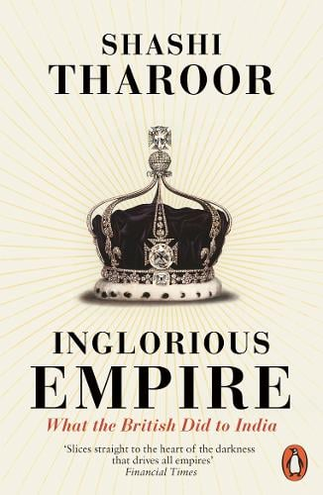 | Inglorious Empire  In the eighteenth century, India's share of the world economy was as large as Europe's. By 1947, after two centuries of British rule, it had decreased six-fold. The Empire blew rebels from cannon, massacred unarmed protesters, entrenched institutionalised racism, and caused millions to die from starvation.  British imperialism justified itself as enlightened despotism for the benefit of the governed, but Shashi Tharoor takes demolishes this position, demonstrating how every supposed imperial 'gift' - from the railways to the rule of law - was designed in Britain's interests alone. He goes on to show how Britain's Industrial Revolution was founded on India's deindustrialisation, and the destruction of its textile industry. In this bold and incisive reassessment of colonialism, Tharoor exposes to devastating effect the inglorious reality of Britain's stained Indian legacy.
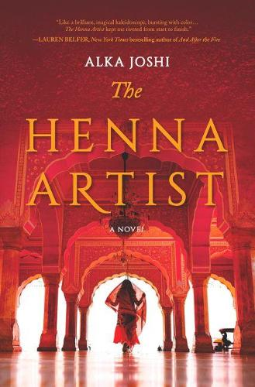 | The Henna Artist  Escaping from an abusive marriage, seventeen-year-old Lakshmi makes her way alone to the vibrant 1950s pink city of Jaipur. There she becomes the most highly requested henna artist--and confidante--to the wealthy women of the upper class. But trusted with the secrets of the wealthy, she can never reveal her own...  Known for her original designs and sage advice, Lakshmi must tread carefully to avoid the jealous gossips who could ruin her reputation and her livelihood. As she pursues her dream of an independent life, she is startled one day when she is confronted by her husband, who has tracked her down these many years later with a high-spirited young girl in tow--a sister Lakshmi never knew she had. Suddenly the caution that she has carefully cultivated as protection is threatened. Still she perseveres, applying her talents and lifting up those that surround her as she does.
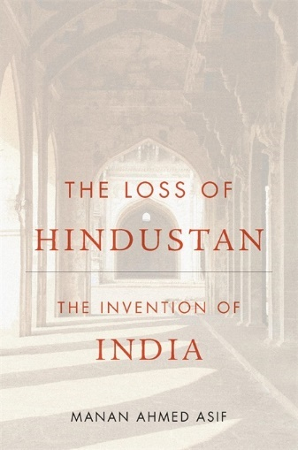 | The Loss of Hindustan  A field-changing history explains how the subcontinent lost its political identity as the home of all religions and emerged as India, the land of the Hindus.  Did South Asia have a shared regional identity prior to the arrival of Europeans in the late fifteenth century? This is a subject of heated debate in scholarly circles and contemporary political discourse. Manan Ahmed Asif argues that Pakistan, Bangladesh, and the Republic of India share a common political ancestry: they are all part of a region whose people understand themselves as Hindustani. Asif describes the idea of Hindustan, as reflected in the work of native historians from roughly 1000 CE to 1900 CE, and how that idea went missing.  This makes for a radical interpretation of how India came to its contemporary political identity. Asif argues that a European understanding of India as Hindu has replaced an earlier, native understanding of India as Hindustan, a home for all faiths. Turning to the subcontinent's medieval past, Asif uncovers a rich network of historians of Hindustan who imagined, studied, and shaped their kings, cities, and societies. Asif closely examines the most complete idea of Hindustan, elaborated by the early seventeenth century Deccan historian Firishta. His monumental work, Tarikh-i Firishta, became a major source for European philosophers and historians, such as Voltaire, Kant, Hegel, and Gibbon during the eighteenth and nineteenth centuries. Yet Firishta's notions of Hindustan were lost and replaced by a different idea of India that we inhabit today. The Loss of Hindustan reveals the intellectual pathways that dispensed with multicultural Hindustan and created a religiously partitioned world of today.
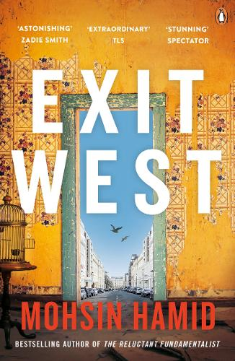 | Exit West  All over the world, doors are appearing.  They lead to other cities, other countries, other lives.  And in a city gripped by war, Nadia and Saeed are newly in love.  Hardly more than strangers, desperate to survive, they open a door and step through.  But the doors only go one way.  Once you leave, there is no going back.
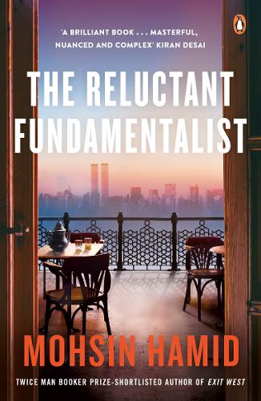 | The Reluctant Fundamentalist  'Excuse me, sir, but may I be of assistance? Ah, I see I have alarmed you. Do not be frightened by my beard. I am a lover of America . . . '  So speaks the mysterious stranger at a Lahore cafe as dusk settles. Invited to join him for tea, you learn his name and what led this speaker of immaculate English to seek you out. For he is more worldy than you might expect; better travelled and better educated. He knows the West better than you do. And as he tells you his story, of how he embraced the Western dream -- and a Western woman -- and how both betrayed him, so the night darkens. Then the true reason for your meeting becomes abundantly clear . . .  Challenging, mysterious and thrillingly tense, Mohsin Hamid's masterly The Reluctant Fundamentalist is a vital read teeming with questions and ideas about some of the most pressing issues of today's globalised, fractured world.
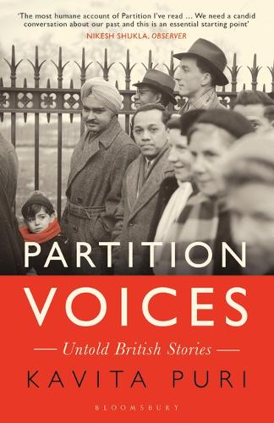 | Partition Voices  The division of the Indian subcontinent in 1947 into India and Pakistan saw millions uprooted and resulted in unspeakable violent. It happened far away, but it would shape modern Britain.  Dotted across homes in Britain are people who were witnesses to one of the most tumultuous events of the twentieth century. But their memory of Partition has been shrouded in silence. In her eye-opening and timely work, Kavita Puri uncovers remarkable testimonies from former subjects of the Raj who are now British citizens - including her father.  Weaving a tapestry of human experience over seven decades, Puri reveals a secret history of ruptured families and friendships, extraordinary journeys and daring rescue missions that reverberates with compassion and loss. It is a work that breaks the silence and confronts the difficult truths at the heart of Britain's shared past with South Asia.  ‘The most humane account of partition I’ve read … We need a candid conversation about our past and this is an essential starting point’ Observer  ‘Opens a fascinating and necessary conversation about contemporary Britain and its people – where they have come from, what they have done and who they may now want to be’ Times Literary Supplement
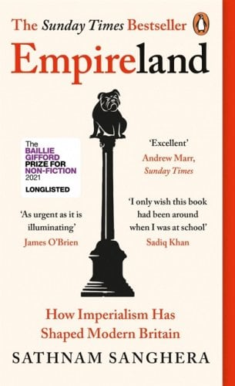 | Empireland  EMPIRE explains why there are millions of Britons living worldwide.  EMPIRE explains Brexit and the feeling that we are exceptional.  EMPIRE explains our distrust of cleverness.  EMPIRE explains Britain's particular brand of racism.  Strangely hidden from view, the British Empire remains a subject of both shame and glorification. In his bestselling book, Sathnam Sanghera shows how our imperial past is everywhere: from how we live and think to the foundation of the NHS and even our response to the COVID-19 crisis.  At a time of great division, when we are arguing about what it means to be British, Empireland is a groundbreaking revelation - a much-needed and enlightening portrait of contemporary British society, shining a light on everything that usually gets left unsaid.
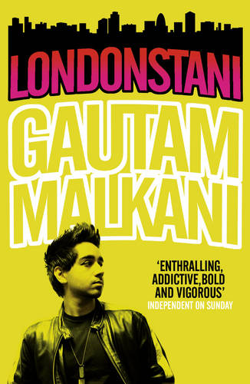 | Londonstani  'Londonstani', Gautam Malkani's electrifying debut, reveals a Britain that has never before been explored in the novel: a country of young Asians and white boys (desis and goras) trying to work out a place for themselves in the shadow of the divergent cultures of their parents' generation.  Set close to the Heathrow feed roads of Hounslow, Malkani shows us the lives of a gang of four young men: Hardjit the ring leader, a Sikh, violent, determined his caste stay pure; Ravi, determinedly tactless, a sheep following the herd; Amit, whose brother Arun is struggling to win the approval of his mother for the Hindu girl he has chosen to marry; and Jas who tells us of his journey with these three, desperate to win their approval, desperate too for Samira, a Muslim girl, which in this story can only have bad consequences. Together they cruise the streets in Amit's enhanced Beemer, making a little money changing the electronic fingerprints on stolen mobile phones, a scam that leads them into more dangerous waters.  Funny, crude, disturbing, written in the vibrant language of its protagonists - a mix of slang, Bollywood, texting, Hindu and bastardised gangsta rap - 'Londonstani' is about many things: tribalism, aggressive masculinity, integration, cross-cultural chirpsing techniques, the urban scene seeping into the mainstream, bling bling economics, 'complicated family-related shit'. It is one of the most surprising British novels of recent years.
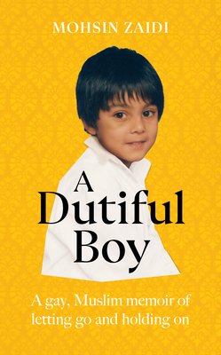 | A Dutiful Boy  A coming of age memoir about growing up queer in a strict Muslim household. Like Educated with a modern British context.  Mohsin grew up in a deprived pocket of east London; his family was close-knit but very religiously conservative. From a young age Mohsin felt different but in a home where being gay was inconceivable he also felt very alone. Outside of home Mohsin went to a failing inner city school where gang violence was a fact of life. As he grew up life didn’t seem to offer teenage Mohsin any choices: he was disenfranchised as a poor, brown boy, and he was isolated from his family as a closet gay Muslim.  However Mohsin had incredible drive and he used education as a way out of his home life and to throw himself into a new kind of life. He became the first person from his school to go to Oxford University and there he found the freedom to come out to his friends. But Oxford was a whole different world with its own huge challenges and Mohsin found himself increasingly conflicted. It came to a head when Mohsin went back to visit his parents only to be confronted by his father and a witchdoctor he'd invited to 'cure' Mohsin.  Although Mohsin's story takes harrowing turns it is full of life and humour, and it ends inspiringly. Through his irrepressible spirit Mohsin breaks through emotional and social barriers and in the end he even finds acceptance from his family. Now Mohsin is a top criminal barrister who fights large-scale cases on a daily basis. Having faced battles growing up, he truly understands the importance of justice as a way of life.
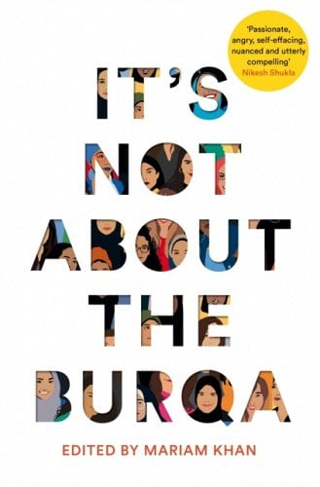 | It’s Not About the Burqa  In 2016, Mariam Khan read that David Cameron had linked the radicalization of Muslim men to the ‘traditional submissiveness’ of Muslim women. Mariam felt pretty sure she didn’t know a single Muslim woman who would describe herself that way. Why was she hearing about Muslim women from people who were neither Muslim, nor female?  Years later the state of the national discourse has deteriorated even further, and Muslim women’s voices are still pushed to the fringes – the figures leading the discussion are white and male.  Taking one of the most politicized and misused words associated with Muslim women and Islamophobia, It’s Not About the Burqa is poised to change all that. Here are voices you won’t see represented in the national news headlines: seventeen Muslim women speaking frankly about the hijab and wavering faith, about love and divorce, about feminism, queer identity, sex, and the twin threats of a disapproving community and a racist country.  With a mix of British and international women writers, from activist Mona Eltahawy's definition of a revolution to journalist and broadcaster Saima Mir telling the story of her experience of arranged marriage, from author Sufiya Ahmed on her Islamic feminist icon to playwright Afshan D'souza-Lodhi's moving piece about her relationship with her hijab, these essays are funny, warm, sometimes sad, and often angry, and each of them is a passionate declaration calling time on the oppression, the lazy stereotyping, the misogyny and the Islamophobia.  What does it mean, exactly, to be a Muslim woman in the West today? According to the media, it’s all about the burqa. Here’s what it’s really about.
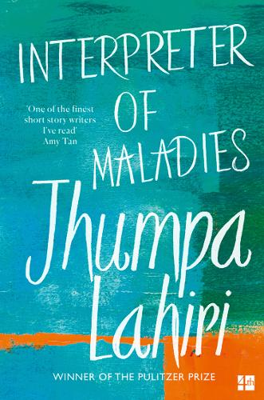 | Interpreter of Maladies  Jhumpa Lahiri’s prize-winning debut collection explores the lives of Indians in exile – of people navigating between the strict traditions they’ve inherited and the baffling New World they must encounter every day.  Whether set in Boston or Bengal, these sublimely understated stories, imbued with umour and subtle detail, speak with eloquence to anyone who has ever felt the yearnings of exile or the emotional confusion of an outsider.
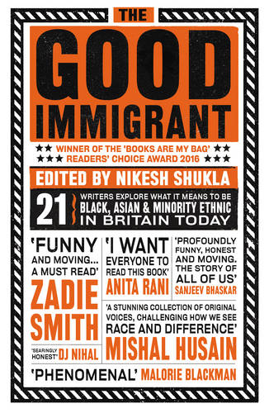 | The Good Immigrant  First published in 2016, The Good Immigrant, has since been hailed as a modern classic and credited with reshaping the discussion about race in contemporary Britain. It brings together a stellar cast of the country’s most exciting voices to reflect on why immigrants come to the UK, why they stay and what it means to be ‘other’ in a place that doesn’t seem to want you, doesn’t truly accept you – however many generations you’ve been here – but still needs you for its diversity monitoring forms.  This 5th anniversary edition, featuring a new preface by editor Nikesh Shukla, shows that the pieces collected here are as poignant, challenging, angry, humorous, heartbreaking and important as ever.
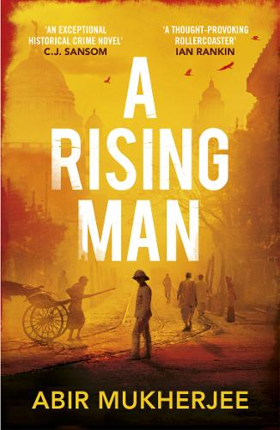 | A Rising Man  India, 1919. Desperate for a fresh start, Captain Sam Wyndham arrives to take up an important post in Calcutta’s police force.  He is soon called to the scene of a horrifying murder. The victim was a senior official, and a note left in his mouth warns the British to leave India - or else.  With the stability of the Empire under threat, Wyndham and Sergeant 'Surrender-not' Banerjee must solve the case quickly. But there are some who will do anything to stop them...
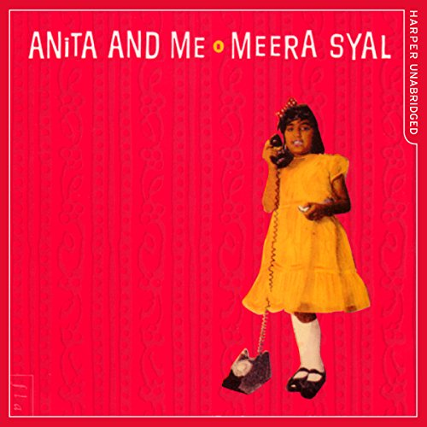 | Anita and Me  Nine-year-old Meena can't wait to grow up and break free from her parents. But as the daughter of the only Punjabi family in the mining village of Tollington, her struggle for independence is different from most. Meena wants fish fingers and chips, not chapati and dhal; she wants an English Christmas, not the usual interminable Punjabi festivities. But more than anything, she wants to roam the backyards of working-class Tollington with feisty Anita Rutter and her gang.  Blonde, cool, aloof, outrageous and sassy, Anita is everything Meena thinks she wants to be. Meena wheedles her way into Anita's life, but the arrival of a baby brother, teenage hormones, impending entrance exams for the posh grammar school and a motorcycling rebel without a future threaten to turn Anita's salad days sour. Anita and Me paints a comic, poignant, compassionate and colourful portrait of village life in the era of flares, power cuts, glam rock, decimalisation and Ted Heath. It is a unique vision of a British childhood in the'70s, a childhood caught between two cultures, each on the brink of change.
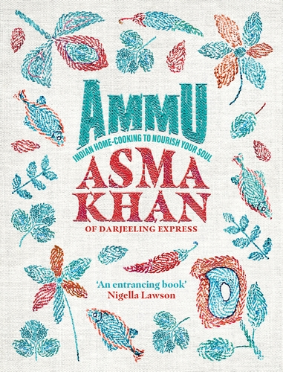 | Ammu  Here’s a reason this cookbook – from the Indian-born British chef behind Darjeeling Express, an all-female-run restaurant in London’s Covent Garden – was the Times’ Cookbook of the Year 2022: more than just a collection of recipes, it’s a joyous celebration of food’s incredible power to comfort, to show love and even to heal.  Dedicated to Khan’s mother, the titular Ammu, and to the home cooking she was raised with, the book covers a banquet table’s span of delicious meals, while remaining focused on the place where love and food truly come together: the family dinner table.
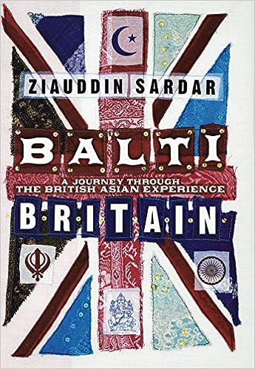 | Balti Britain  Sardar travels to the main Asian communities in the UK, to Leicester and Birmingham, Glasgow and Bradford, Tower Hamlets and Oldham, to tell the history of Asians in Britain - from the arrival of the first Indian in Britain in 1614, through the entagled days of colonialism, to the young extremists in Walthamstow mosque in 2006. He interweaves throughout an illuminating account of his own life, describing his carefree childhood in Pakistan, his family's emigration to racist 1950s Britain, and his adulthood straddling two cultures. Along the way he questions: are arranged marriages a good thing? Does the term 'Asian' obscure more than it conveys? Do Vindaloo and Balti actually exist? How far does 'the disease that is in us is of us and within us' describe Islamic terrorism? And is multiculturalism an impossible dream?Funny, surprising, touching and controversial, "Balti Britain" is a fascinating blend of history, reportage and memoir, which will make all Britons, Asian or otherwise, see their country through fresh eyes.

Black History Books
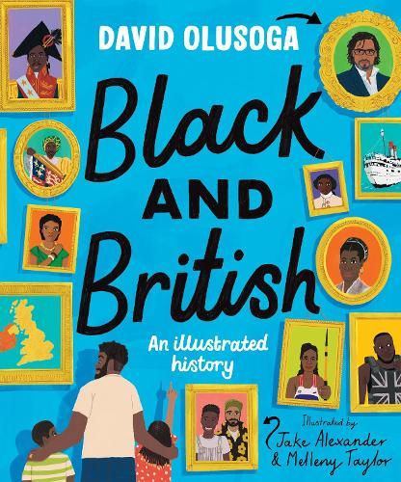 | Black and British  The essential starting place for anyone who wants to learn about Black British History. David Olusoga’s thought provoking text charts the forgotten histories of Black people in Britain from Roman times right through to the present day.  From Roman Africans guarding Hadrian’s Wall, to an African trumpeter in the court of Henry the Eighth, Black Georgians fighting for the abolition of slavery, Black soldiers fighting for Britain in the First World War, Windrush and right up today. These are the stories that brought us all together in this country..
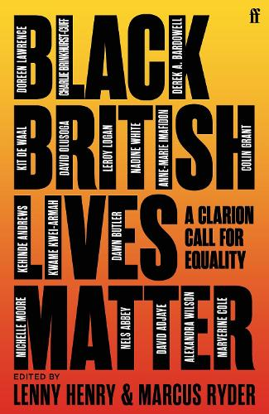 | Black British Lives Matter – Lenny Henry & Marcus Ryder  In response to the international outcry at George Floyd's death, Lenny Henry and Marcus Ryder have commissioned this collection of essays to discuss how and why we need to fight for Black lives to matter - not just for Black people but for society as a whole.  Recognising Black British experience within the Black Lives Matter movement, seventeen prominent Black figures explain why Black lives should be celebrated when too often they are undervalued. Drawing from personal experience, they stress how Black British people have unique perspectives and experiences that enrich British society and the world; how Black lives are far more interesting and important than the forces that try to limit it.  'We achieve everything not because we are superhuman. We achieve the things we achieve because we are human. Our strength does not come from not having any weaknesses, our strength comes from overcoming them' - Doreen Lawrence.
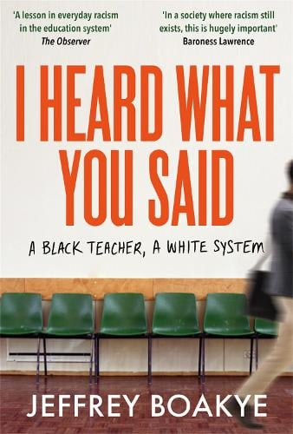 | I Heard what you Said – Jeffrey Boakye  Before Jeffrey Boakye was a black teacher, he was a black student. Which means he has spent a lifetime navigating places of learning that are white by default. Since training to teach, he has often been the only black teacher at school. At times seen as a role model, at others a source of curiosity, Boakye's is a journey of exploration - from the outside looking in.  In the groundbreaking I Heard What You Said, he recounts how it feels to be on the margins of the British education system. As a black, male teacher - an English teacher who has had to teach problematic texts - his very existence is a provocation to the status quo, giving him a unique perspective on the UK's classrooms.  Told through a series of eye-opening encounters based on the often challenging and sometimes outrageous things people have said to him or about him - from 'Can you rap?' and 'Have you been in prison?' to 'Stephen who?' - Boakye reflects with passion and wit on what he has found out about the presumptions, silences and distortions that underpin the experience of black students and teachers.
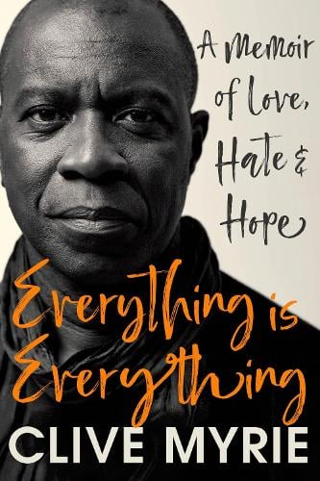 | Everything is Everything – Clive Myrie  As a Bolton teenager with a paper round, Clive Myrie read all the newspapers he delivered from cover to cover and dreamed of becoming a journalist. In this deeply personal memoir, he tells how his family history has influenced his view of the world, introducing us to his Windrush generation parents, a great grandfather who helped build the Panama Canal, and a great uncle who fought in the First World War, later to become a prominent police detective in Jamaica.  He reflects on how being black has affected his perspective on issues he's encountered in thirty years reporting some of the biggest stories of our time (most recently from Ukraine), showing us how those experiences gave him a better idea of what it means to be an outsider. He tells of his pride in his roots, but his determination not to be defined by his background in dealing with the challenges of race and class to succeed at the highest level.  Moving, engaging, revealing, Everything is Everything is a story of love and hate - but also hope.
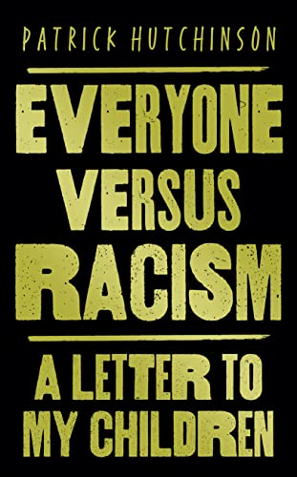  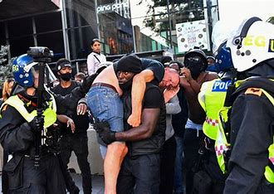 | Everyone versus Racism – A letter to my Children  Patrick Hutchinson  ‘I just want equality, equality for all of us. At the moment, the scales are unfairly balanced and I just want things to be fair for my children, my grandchildren and future generations.’  On 13 June 2020, Patrick Hutchinson, a black man, was photographed carrying a white injured man to safety during a confrontation in London between Black Lives Matter demonstrators and counter-protestors. The powerful image was shared and discussed all around the world.  Everyone versus Racism is a poignant letter from Patrick to his children and grandchildren. Writing from the heart, he describes the realities of life as a black man today and why we must unite to inspire change for generations to come.
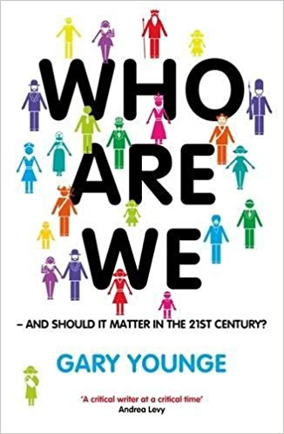 | Who are we – and should it matter in the 21st century? Gary Younge  We are more alike than we are unalike. But the way we are unalike matters. To be male in Saudi Arabia, Jewish in Israel or white in Europe confers certain powers and privileges that those with other identities do not have. In other words identity can represent a material fact in itself.’  Gary Younge demonstrates, in his urgent and brilliantly illuminating new book, that how we define ourselves affects every part of our lives: from violence on the streets to international terrorism; from changes in our laws to whom we elect; from our personal safety to military occupations. Moving between fascinating memoir and searing analysis, from beauty contests in Ireland to the personal views of Tiger Woods, from the author’s own terrifying student days in Paris to the truth behind the Danish cartoons controversy, Gary Younge makes surprising and enlightening connections and a devastating critique of the way our society really works.
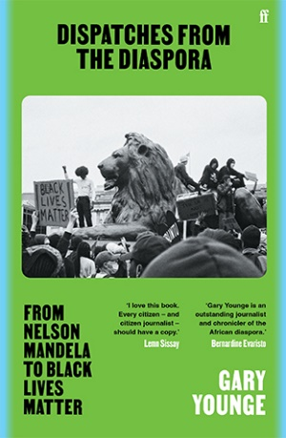 | Dispatches from the Diaspora - Gary Younge  From Nelson Mandela to Black Lives Matter  Reflecting on three decades of his remarkable career as a journalist, Dispatches from the Diaspora is a powerful collection of his writings on race, racism, and Black life and death.  A vital and richly researched blend of reportage, memoir and polemic, it invites us ringside with Younge during some of the most history-defining events of the last century: Obama’s victory, Hurricane Katrina’s devastation of New Orleans, Nelson Mandela’s first election campaign and more.
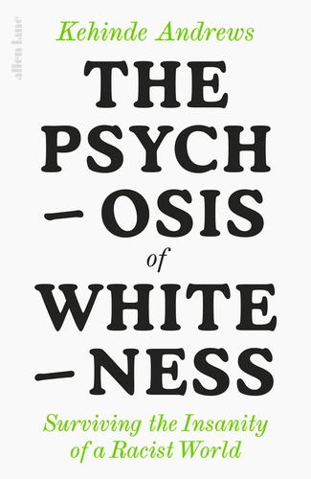 | The Psychosis of Whiteness – Kehinde Andrews  Take a step through the looking-glass to a strange land, one where Piers Morgan is a voice worth listening to about race, where white people buy self-help books to help them cope with their whiteness, where Boris Johnson and Donald Trump are seen by the majority of the population as 'the right (white) man for the job'. Perhaps you know it. All the inhabitants seem to be afflicted by serious delusions, for example that racism doesn't exist and if it does it can be cured with a one-hour inclusion seminar, and bizarre collective hallucinations, like the widely held idea that Britain's only role in slavery was to abolish it.  But there is a serious side too. Society cannot face up to the racism at its heart and in its history, so the delusions, irrationalities and hallucinations it conjures up to avoid doing so can only best be described as a psychosis, with the costs being borne by the sons and daughters of that racist history. Living in a racist world is like living in a world that bears no resemblance to reality. Black and brown people suffer from a greater number of mental health difficulties too, caused in no small part by trying to survive a racist society.  Kehinde Andrews is your piercing, wry and not a little funny guide back to sanity, unpicking the absurd and outrageous lies society tells to keep up the status quo. The Psychosis of Whiteness is your lifeboat out of this topsy-turvy world.
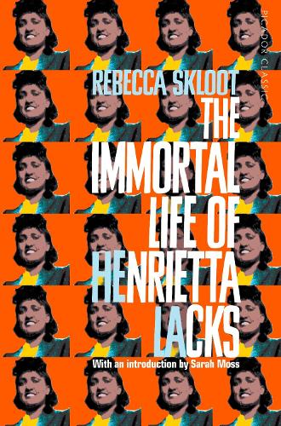 | The Immortal Life of Herietta Lacks – Rebecca Skloot  Her name was Henrietta Lacks, but scientists know her as HeLa. Born a poor black tobacco farmer, her cancer cells - taken without her knowledge - became a multimillion-dollar industry and one of the most important tools in medicine. Yet Henrietta's family did not learn of her 'immortality' until more than twenty years after her death, with devastating consequences . . .  Rebecca Skloot's fascinating account is the story of the life, and afterlife, of one woman who changed the medical world for ever. Balancing the beauty and drama of scientific discovery with dark questions about who owns the stuff our bodies are made of, The Immortal Life of Henrietta Lacks is an extraordinary journey in search of the soul and story of a real woman, whose cells live on today in all four corners of the world.
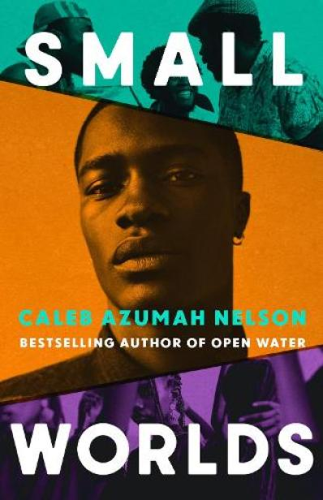 | Small Worlds – Caleb Azumah Nelson  Set over the course of three summers, Small Worlds follows Stephen, a first-generation Londoner born to Ghanian immigrant parents, brother to Ray, and best friend to Adeline. On the cusp of big life changes, Stephen feels pressured to follow a certain path–a university degree, a move out of home–but when he decides instead to follow his first love, music, his world and family fractures in ways he didn’t foresee. Now Stephen must find a path and peace for himself: a space he can feel beautiful, a space he can feel free.
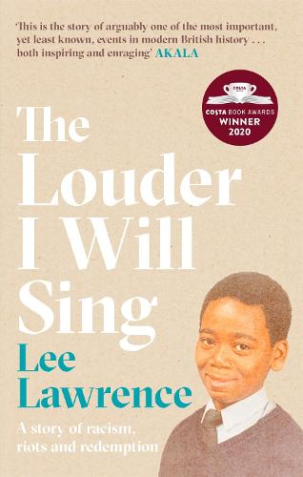 | The Louder I will Sing – Lee Lawrence  What would you do if the people you trusted to uphold the law committed a crime against you? Who would you turn to? And how long would you fight them for?  On 28th September 1985, Lee Lawrence's mother Cherry Groce was wrongly shot by police during a raid on her Brixton home. The bullet shattered her spine and she never walked again. In the chaos that followed, 11-year-old Lee watched in horror as the News falsely pronounced his mother dead. In Brixton, already a powder keg because of the deep racism that the community was experiencing, it was the spark needed to trigger two days of rioting that saw buildings brought down by petrol bombs, cars torched and shops looted.  But for Lee, it was a spark that lit a flame that would burn for the next 30 years as he fought to get the police to recognise their wrongdoing. His life had changed forever: he was now his mother's carer, he had seen first-hand the prejudice that existed in his country, and he was at the mercy of a society that was working against him. And yet that flame - for justice, for peace, for change - kept him going.  The Louder I Will Sing is a powerful, compelling and uplifting memoir about growing up in modern Britain as a young Black man. It's a story both of people and politics, of the underlying racism beneath many of our most important institutions, but also the positive power that hope, faith and love can bring in response.
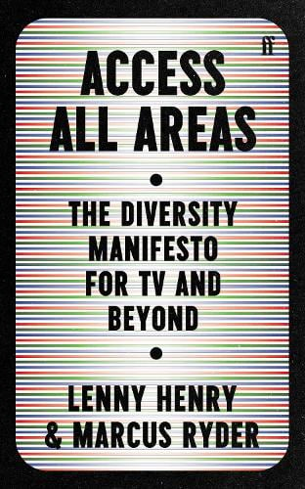 | Access all Areas – Lenny Henry & Marcus Ryder  Sir Lenny Henry rang up the Office for National Statistics to confirm something he'd been thinking about for a long time. They told him that only 29.5% of the United Kingdom's population is made up of white, heterosexual, able-bodied men; so, he wonders, why do they still make up the vast majority of people we see in our media?  Joining forces with the former Chair of the Royal Television Society's Diversity Committee Marcus Ryder, he draws on decades of experience to reveal why recent efforts to diversify media have been thus far ineffective, and why they are simply not enough. With wit, humour and unflinching gravitas they analyse the flaws of current diversity initiatives, point out the structural and financial imbalances working against the cause, and provide clear solutions to get the media industry back on track.  Access All Areas is an urgent, actionable manifesto that will dramatically shift the debate around diversity and the media.
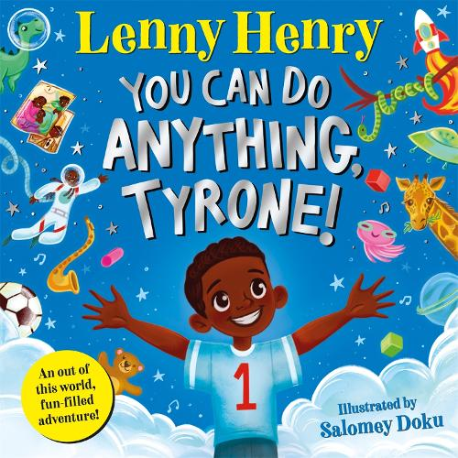 | You Can Do Anything, Tyrone! Lenny Henry  A fantastic fun tale of imagination and adventure from the award-winning comedian and actor Sir Lenny Henry.  Tyrone is going to build a brilliant rocket ship out of building blocks and go on an adventure to the moon! There's just one problem . . . the blocks won't work, and Tyrone quickly loses his temper. Luckily, Grandad Cleveland is on hand to show him that with self belief, a bit of determination and a lot of imagination, there's nothing Tyrone can't do.  In fact, why stop at the moon when there's the rest of the world and a whole universe to explore! A highly entertaining rhyming story full of love, family and fun - brilliantly brought to life by illustrator Salomey Doku.
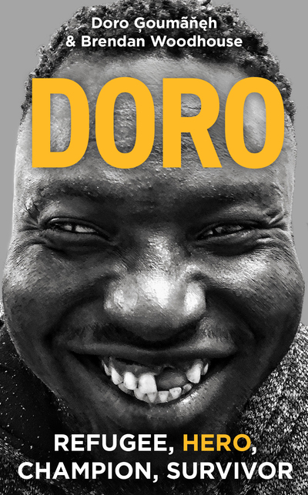 | Doro – Doro Goumaneh and Brendan Woodhouse  ‘This is Doro and he is beautiful.’  So begins the extraordinary story of Doro Ģoumãňęh, who faced an unimaginable series of adversities on his journey from persecution in The Gambia to refuge in France.  Doro was once a relatively prosperous fisherman, but in 2014, when the country’s fishing rights were stolen and secret police began arresting Gambian fishermen, Doro left home, fleeing for his life. From Senegal to Libya to Algeria and back to Libya, Doro fell victim to the horrific cycle of abuse targeted at refugees. He endured shipwrecks, torture and being left for dead in a mass grave. Miraculously, he survived.  In 2019, during one of his many attempts to reach Europe, Doro was rescued by the boat Sea-Watch 3 in the Mediterranean, where he met volunteer Brendan Woodhouse. While waiting out a two-week standoff – floating off the coast of Sicily, as political leaders accused Sea-Watch, a German organisation that helps migrants, of facilitating illegal entry to Europe – a great friendship formed.  Told through both Doro’s and Brendan’s perspectives, Doro  touches on questions of policy and politics, brutality and bravery, survival and belonging – issues that confront refugees everywhere. But ultimately it is one man's incredible story – that of Doro: refugee, hero, champion, survivor and friend.
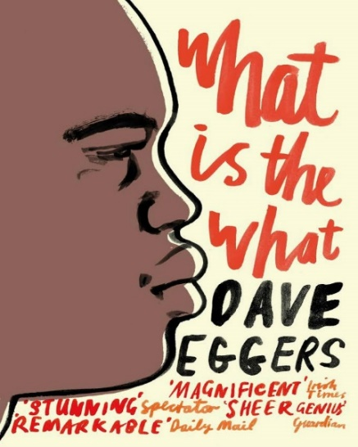 | What is the What – Dave Eggers  Valentino Achak Deng is just a boy when conflict separates him from his family and forces him to leave his small Sudanese village, joining thousands of other orphans on their long, long walk to Ethiopia, where they find safety - for a time. Along the way Valentino encounters enemy soldiers, liberation rebels and deadly militias, hyenas and lions, disease and starvation. But there are experiences ahead that will test his spirit in even greater ways than these . . .  Truly epic in scope, and told with expansive humanity, deep compassion and unexpected humour, What is the What is an eye-opening account of life amid the madness of war and an unforgettable tale of tragedy and triumph.
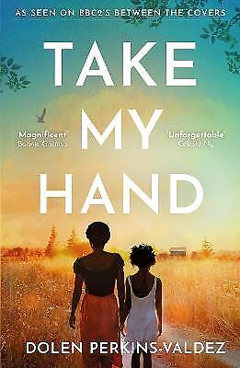 | Take my Hand – Dolen Perkins-Valdez  Inspired by true events that rocked the nation, a profoundly moving novel about a Black nurse in post-segregation Alabama who blows the whistle on a terrible wrong done to her patients, from the New York Times bestselling author of Wench.  Montgomery, Alabama 1973. Fresh out of nursing school, Civil Townsend has big plans to make a difference, especially in her African American community. At the Montgomery Family Planning Clinic, she intends to help women make their own choices for their lives and bodies.  But when her first week on the job takes her down a dusty country road to a worn down one-room cabin, she’s shocked to learn that her new patients are children—just 11 and 13 years old. Neither of the Williams sisters has even kissed a boy, but they are poor and Black and for those handling the family’s welfare benefits that’s reason enough to have the girls on birth control. As Civil grapples with her role, she takes India, Erica and their family into her heart. Until one day, she arrives at the door to learn the unthinkable has happened and nothing will ever be the same for any of them.  Decades later, with her daughter grown and a long career in her wake, Dr. Civil Townsend is ready to retire, to find her peace and to leave the past behind. But there are people and stories that refuse to be forgotten. That must not be forgotten. Because history repeats what we don’t remember.
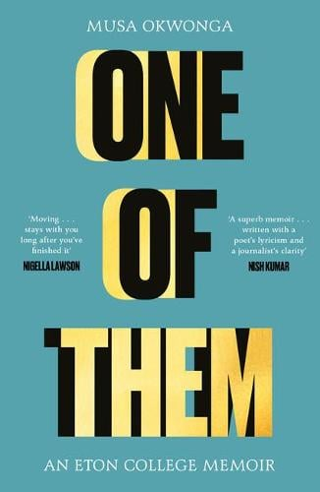 | One of Them - Musa Okwonga  A young Black man who grew up in a predominantly working-class town - was not your typical Eton College student.  The experience moulded him, challenged him... but also made him wonder why a place that was so good for him also seems to contribute to the harm being done to the UK. The more he searched, the more evident the connection became between one of Britain's most prestigious institutions and the genesis of Brexit, and between his home town in the suburbs of Greater London and the rise of the far right.  Woven throughout this deeply personal and unflinching memoir of Musa's five years at Eton in the 1990s is a present-day narrative which engages with much wider questions about pressing social and political issues: privilege, the distribution of wealth, the rise of the far right in the UK, systemic racism, the 'boys' club' of government and the power of the few to control the fate of the many. One of Them is both an intimate account and a timely exploration of race and class in modern Britain.
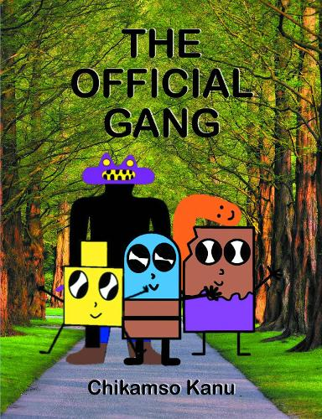 | The Official Gang – Chikamso Kanu  The Official Gang is set in an imaginary world of intriguing characters making up a gang. This epic tale is full of fun and humour as well as serious subjects such as bullies, jealousy, fighting and health.  ** a note to say that a friend’s son has just written this
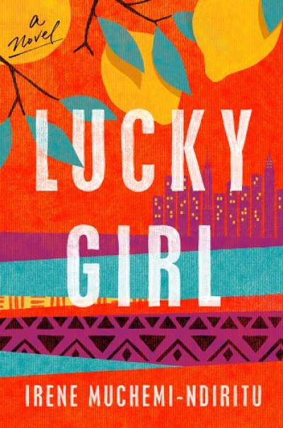 | Lucky Girl – Irene Muchemi-Ndiritu  Since I was a child I had been searching for a place where I could just be me. It wasn’t at home in Kenya with Mother. Then I came to a foreign land, which I loved, but I was still a stranger. I was different, even to the people with whom I shared a skin color and hair texture. I worried I would never find the place where I belonged.  Soila is a lucky girl by anyone’s estimation. Raised by her stern, conservative mother and a chorus of aunts, she has lived a life of privilege in Nairobi. Soila is headstrong and outspoken, and she chafes against her mother’s strict rules. After a harrowing assault by a trusted family friend, she flees to New York for college, vowing never to return home.  New York in the 1990s is not what she imagined it would be. Instead of a golden land of opportunity, Soila finds herself shocked by the entitlement of her wealthy American classmates and the poverty she sees in the streets. She befriends a Black American girl at school and witnesses the insidious acts of racism her friend endures, forcing Soila to begin to acknowledge the legacy of slavery and the blind spots afforded by the privilege of her Kenyan upbringing. When she falls in love with a free-spirited artist, a man her mother would never approve of, she must decide whether to honor her Kenyan identity and what she owes to her family, or to follow her heart and forge a life of her own design.
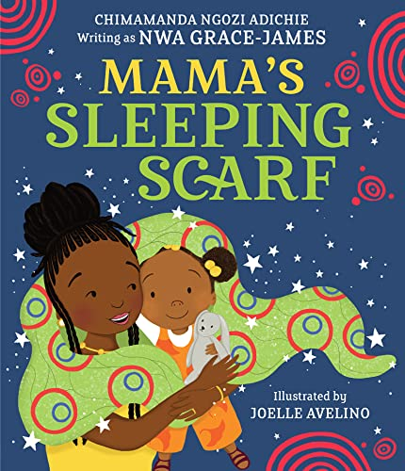 | Mama’s Sleeping Scarf – Chimamanda Ngozi Adichie  A joyful exploration of family life, written by one of the most outstanding contemporary authors of our generation.  This beautiful family story follows a young girl called Chino as she plays with her mama's sleeping scarf through the day. Running with the scarf, Chino weaves together little incidentals of home life into a glorious celebration of the power of a mother-daughter relationship, and the gentle joys that build a perfect day. Exquisitely written with compelling simplicity, this is a heartfelt homage to family love.  A compelling debut picture book from one of the most important voices in literature today, brought into glorious technicolour through the vibrant and contemporary illustrations of Joelle Avelino.
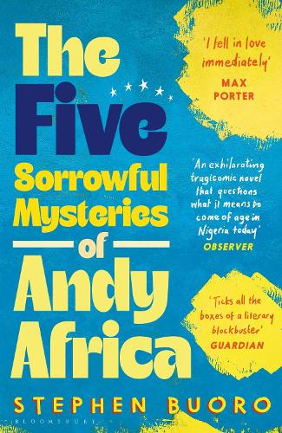 | The Five Sorrowful Mysteries of Andy Africa is a heartwrenching coming-of-age story about teen Andy Aziza. Living in colonized Nigeria, a country torn by violence, Andy spends his time contemplating everything from mathematical theorems to Black power.  Yet, Andy’s world is shook on the afternoon of a church party held. A man arrives claiming to be Andy’s father while an anti-Christian mob is approaching the church with threats of violence.  This debut novel by Stephen Buoro grapples with identity and contemporary African life all through its beautiful prose.
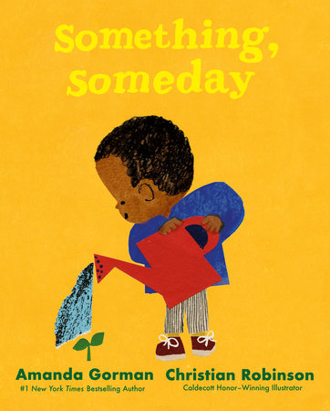 | Sometimes the world feels broken. And problems seem too big to fix. But somehow, we all have the power to make a difference. With a little faith, and maybe the help of a friend, together we can find beauty and create change.  With intimate and inspiring text and powerfully stunning illustrations, Something, Someday reveals how even the smallest gesture can have a lasting impact.

